**Lab Exercise 20**

**Creating a Pipeline Script**

**Objective:** To create a pipeline script for automating build processes in Jenkins

**Tools required:** Jenkins

**Prerequisites:** None

Steps to be followed:

1. Log in to the Jenkins CI tool and create a pipeline script

**Step 1: Log in to the Jenkins Cl tool and create a pipeline script**

1. Open the browser, go to the Jenkins **Dashboard** by typing **localhost:8080** in your browser, provide the credentials, and click the **Sign in** button

|  |
| --- |
| **Note:** The credentials for accessing Jenkins in the lab are Username: **admin** and Password: **admin**. |

1. Click on the **New Item** option as shown in the screenshot below:

1. Enter a desired name for the project, select **Pipeline**, and then click on **OK** as shown in the screenshot below:

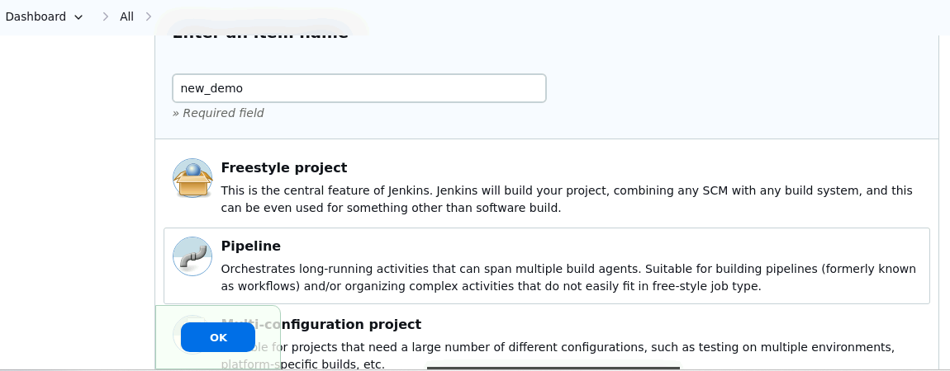

1. Click on **Pipeline** as shown in the screenshot below:

1. Enter the following pipeline script in the script editor and click on **Save** as shown in the screenshot below:

**pipeline {**

**agent any**

**stages {**

**stage("hello") {**

**steps{**

**echo"welcome to Jenkins pipeline"**

**}**

**}**

**}**

**}**

**Output:-**

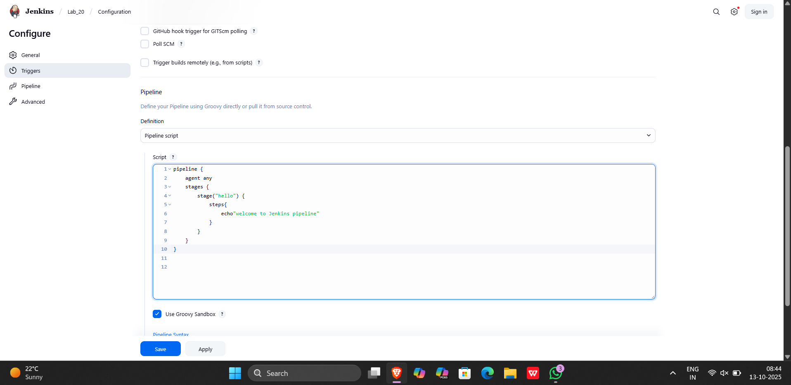

1. Click on **Build Now** to run the pipeline script as shown in the screenshot below:

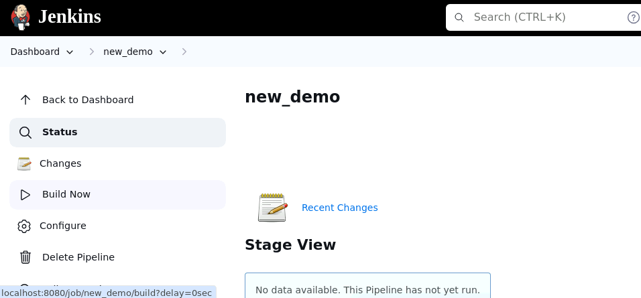

1. Hover over the milliseconds number next to the build stage name as shown in the screenshot below:

|  |
| --- |
| **Note:** Ensure that you hover the cursor over the milliseconds number without clicking on it |

1. Click on **Logs** as shown in the screenshot below:

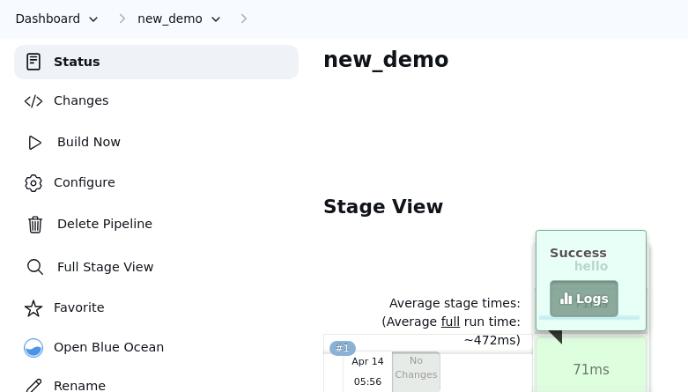

Check for the message in the top-left corner to confirm the successful execution of the pipeline stage as shown in the screenshot below:

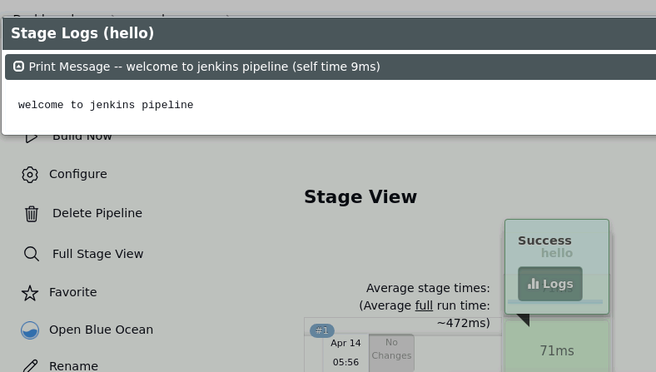

By following these steps, you have successfully created a pipeline script for automating build processes in Jenkins.

**Output:-**

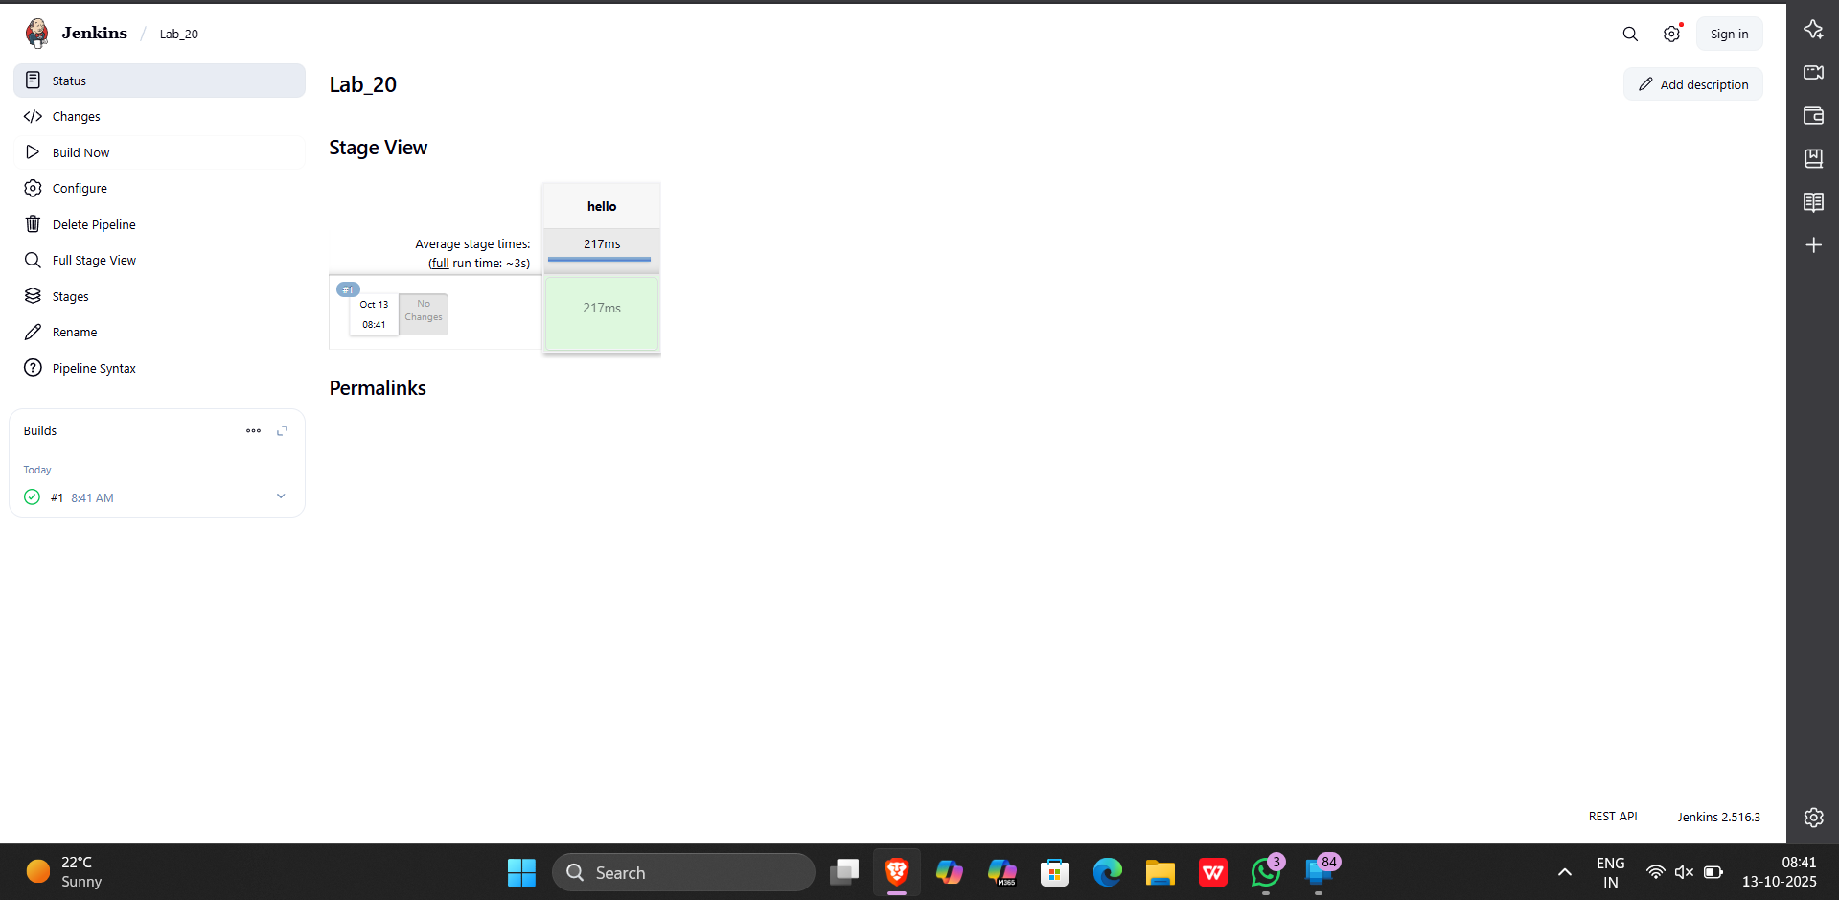

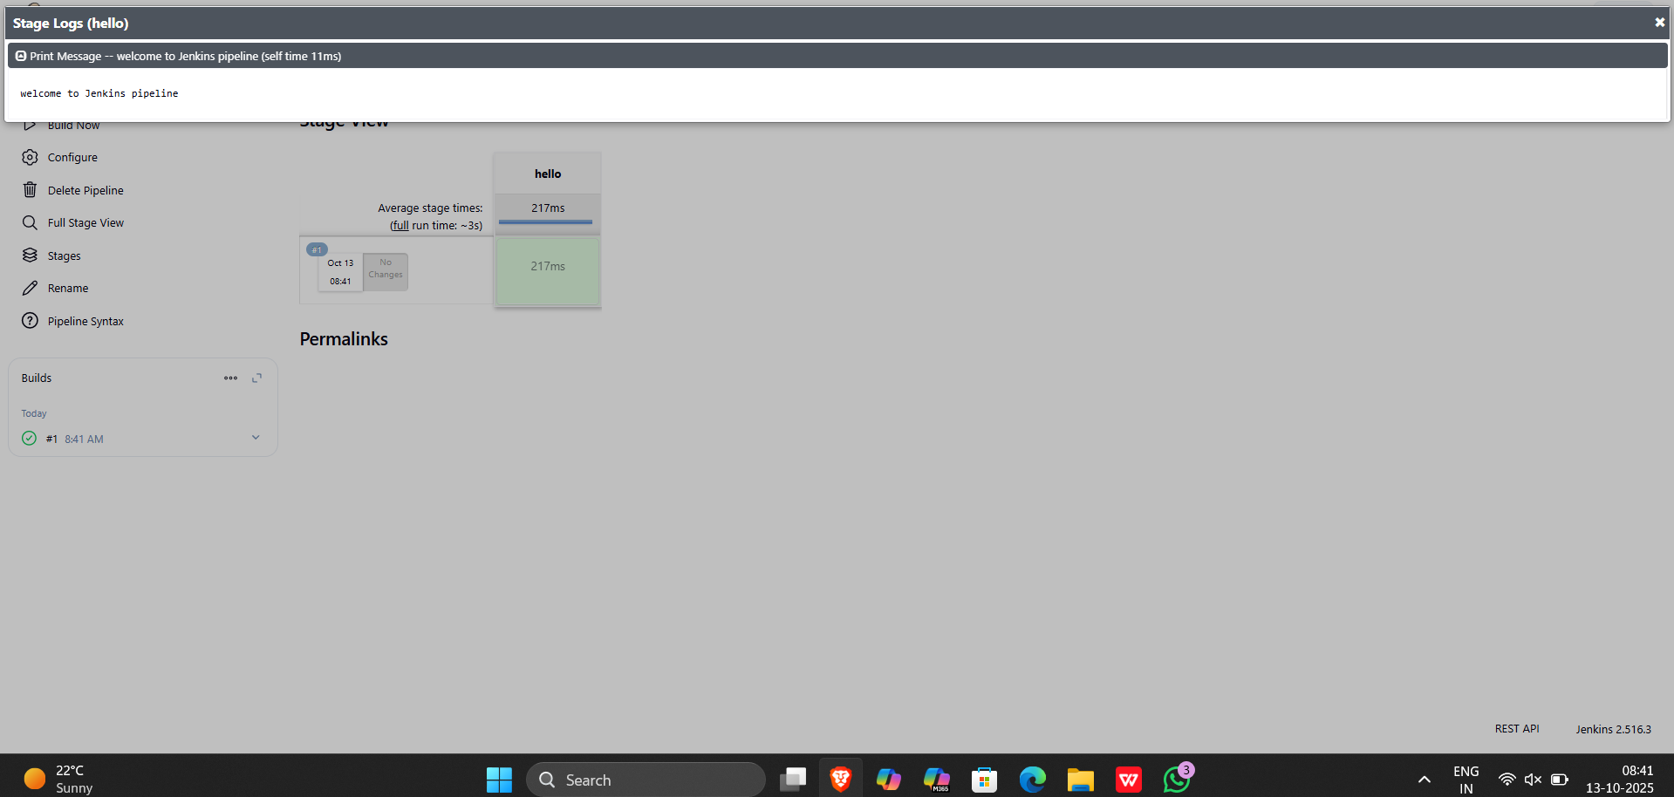

Creating a pipeline for a project

1) Create a built using pipeline

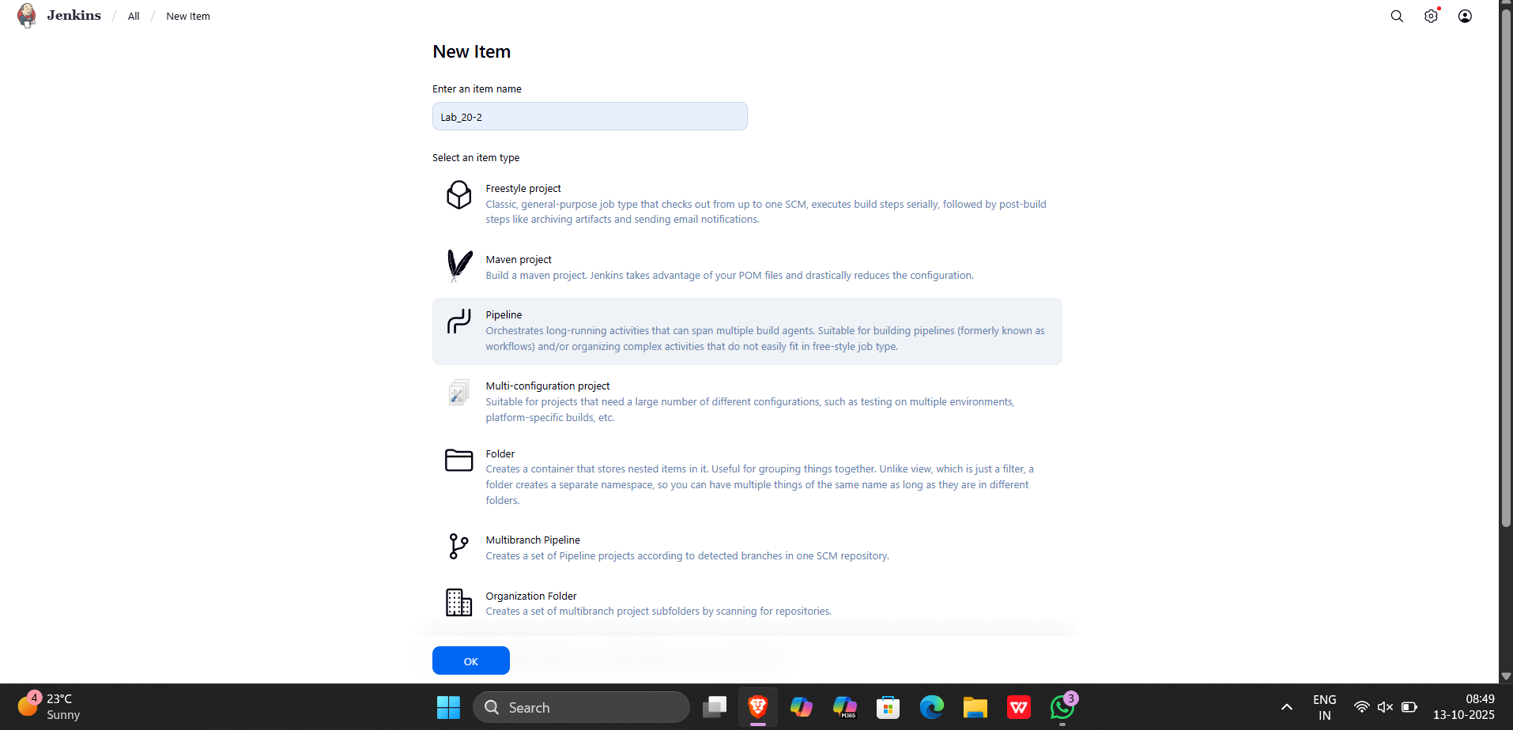

2) write the script for the pipeline in jenkinsfile in github

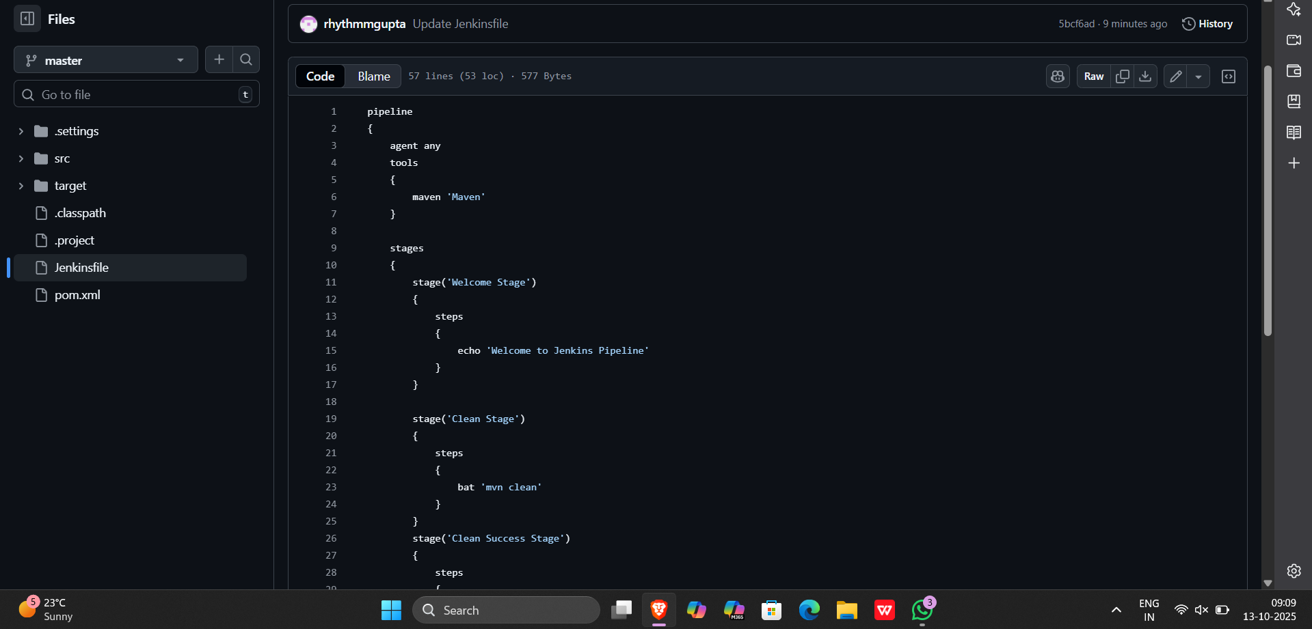

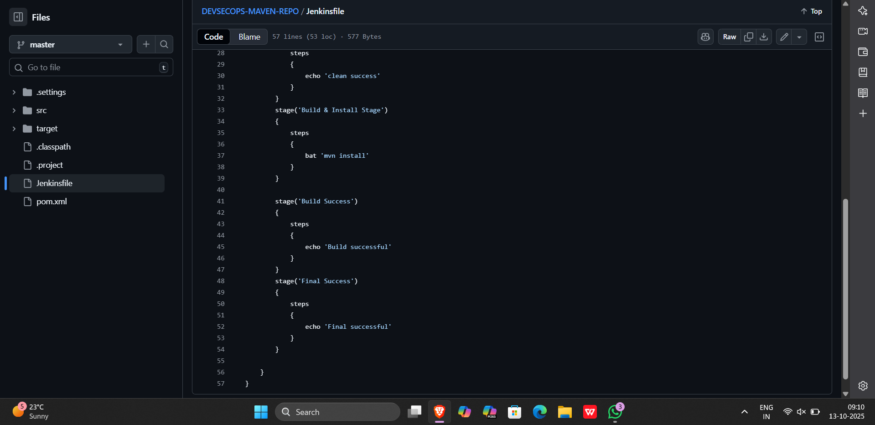

3) Add the repository url in github project and in pipeline

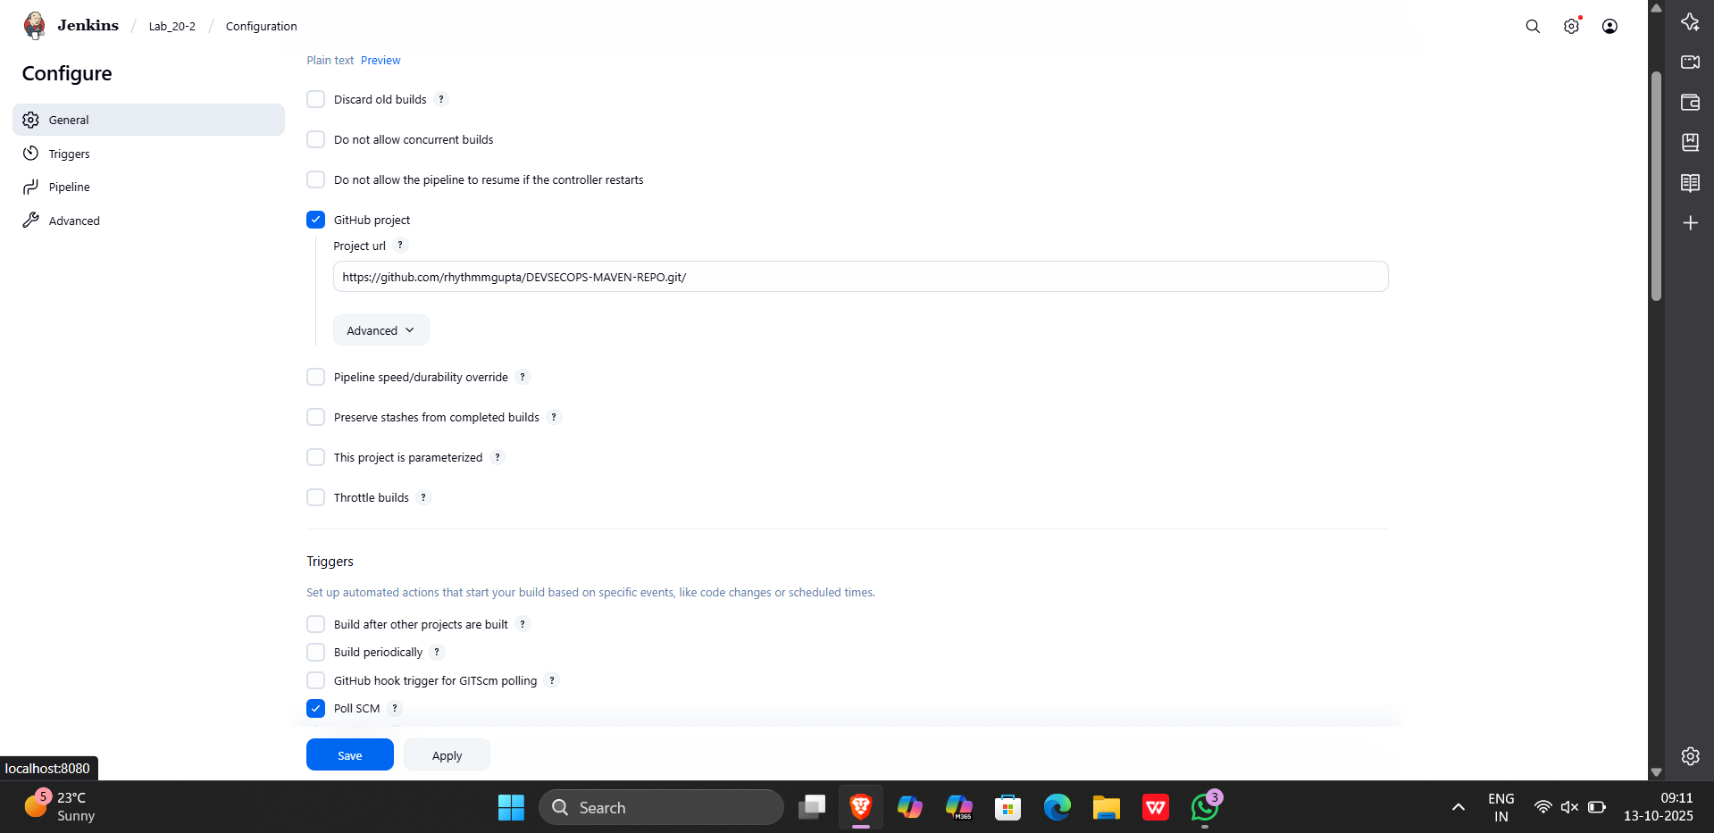

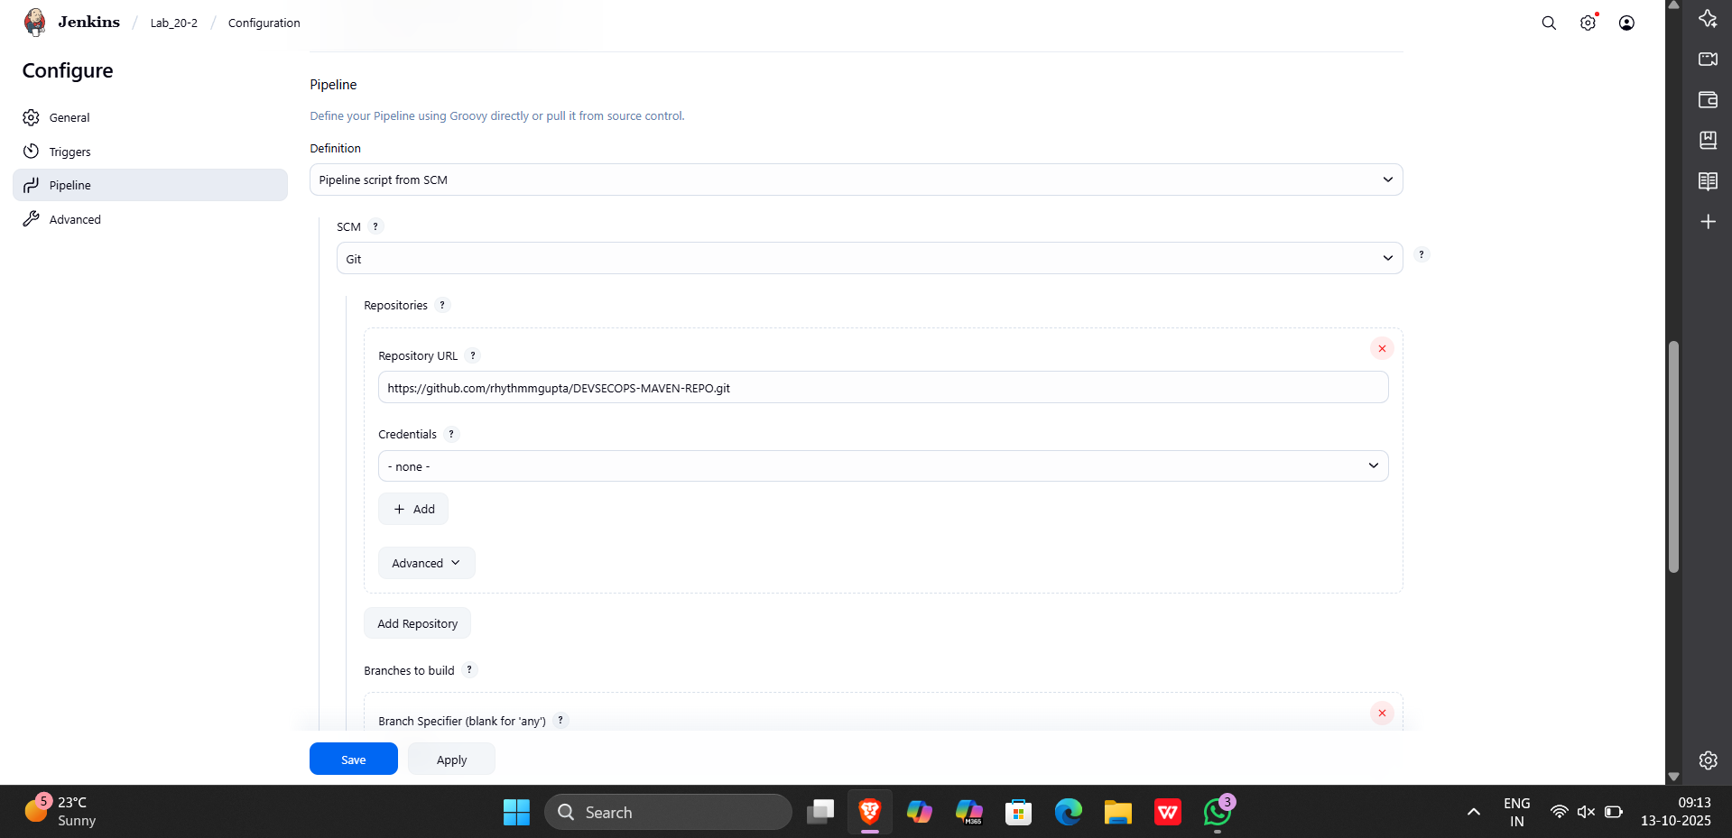

4) check poll scm option

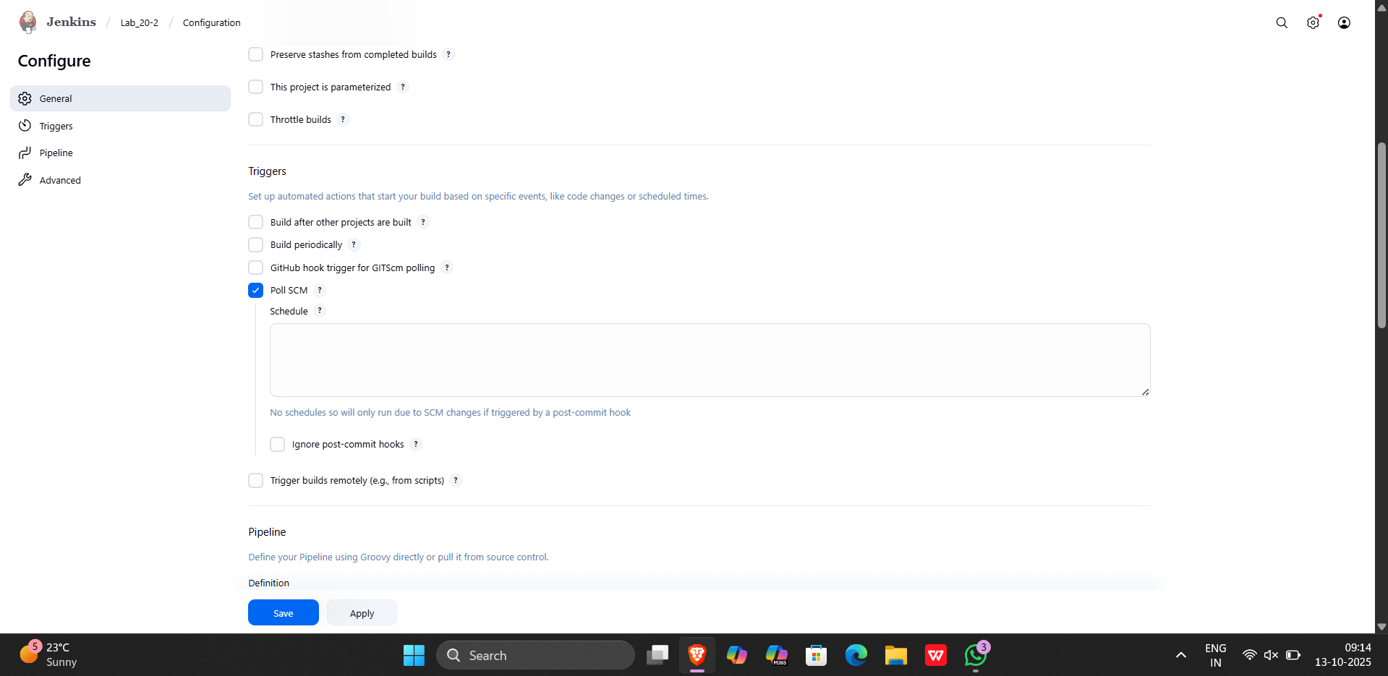

Output:-

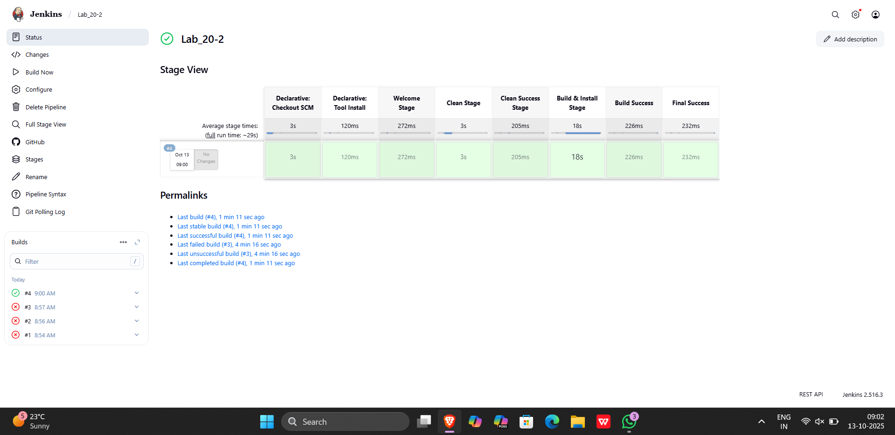

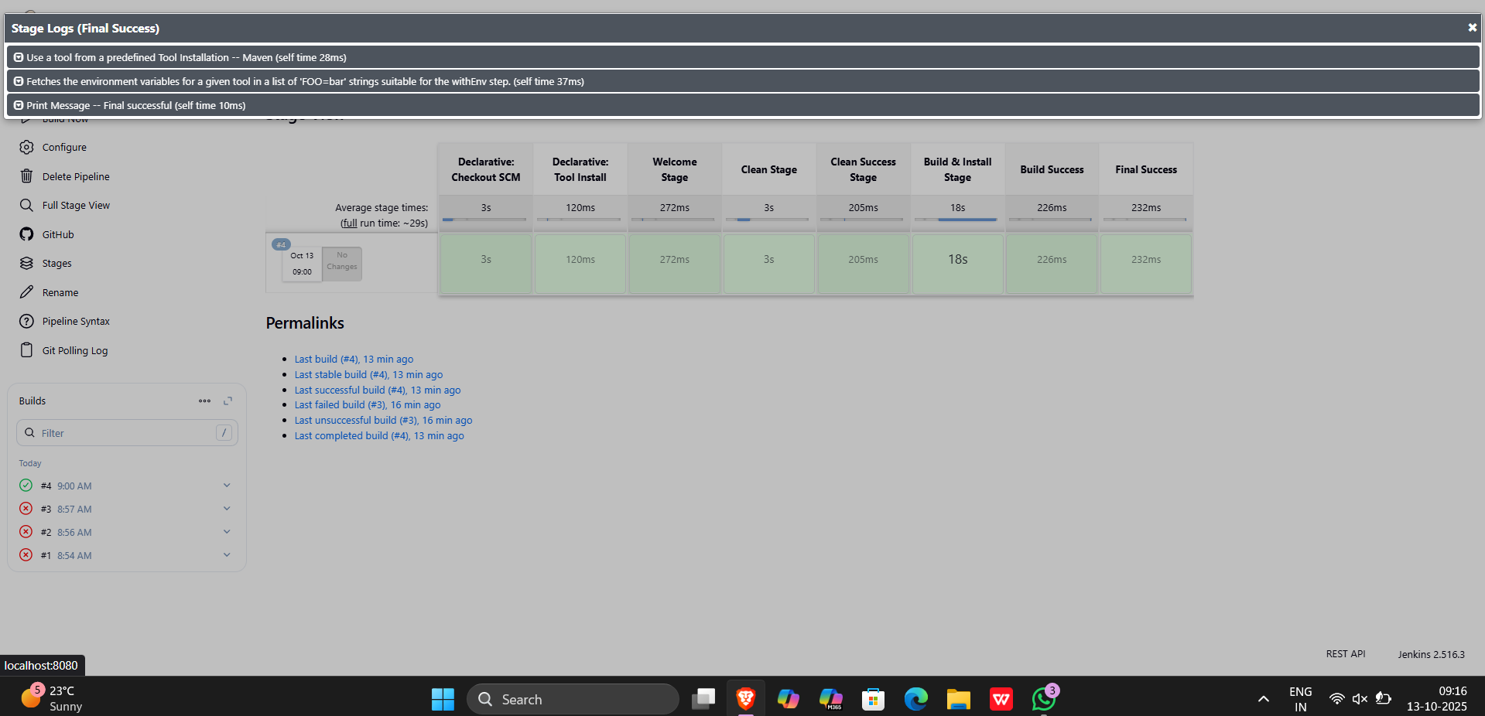

**Pipeline script**

pipeline

{

agent any

tools

{

maven 'Maven'

}

stages

{

stage('Welcome Stage')

{

steps

{

echo 'Welcome to Jenkins Pipeline'

}

}

stage('Clean Stage')

{

steps

{

bat 'mvn clean'

}

}

stage('Clean Success Stage')

{

steps

{

echo 'clean success'

}

}

stage('Build & Install Stage')

{

steps

{

bat 'mvn install'

}

}

stage('Build Success')

{

steps

{

echo 'Build successful'

}

}

stage('Final Success')

{

steps

{

echo 'Final successful'

}

}

}

}